

**Golden-Gate Int’l College**

Affiliated to Tribhuvan University

Old Baneswor, Kathmandu

**A**

**Lab Report on**

**Mobile Programming**

**(CACS 351)**

**Lab Title: Android UI Components Lab: Menus, Dialogs, and Adapter Views**

**Lab Sheet No: 2**

|  |  |
| --- | --- |
| **Submitted by:** | **Submitted to:** |
| Name: Surakshya Lama | Mr. Deepak Thakur |
| Roll no:15 | Submission date: 11th May, 2025 |
| Registration no:6-2-453-15-2021 |  |

**Task 2.1:**

**Create a menu driven android app that contains simple interest and area of triangle. Create separate fragment for each menu and perform task as their name.**

menu/main.xml:

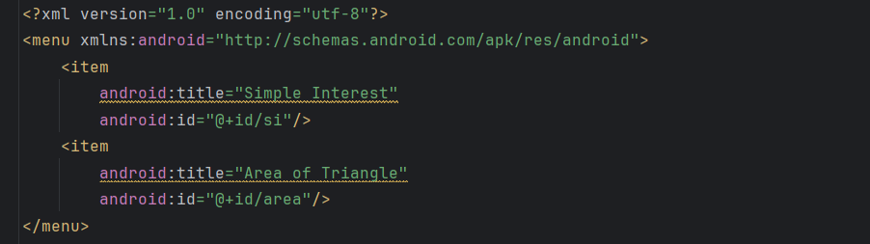

layout.xml:

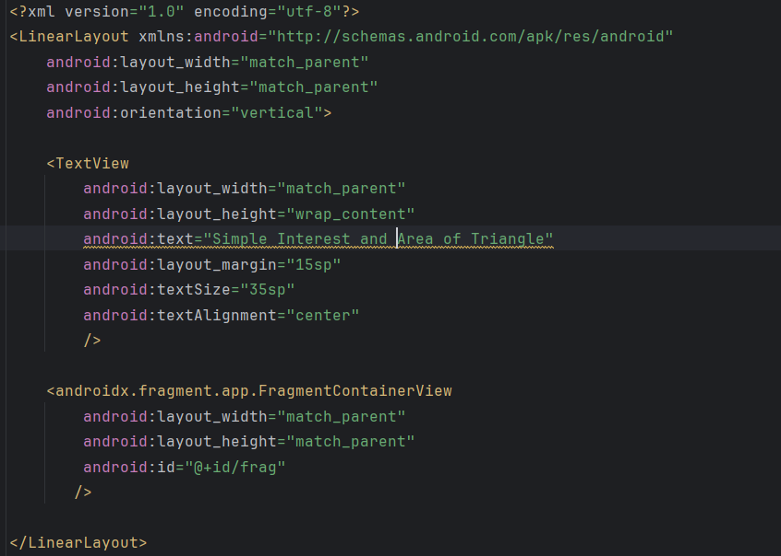

fragment_si.xml: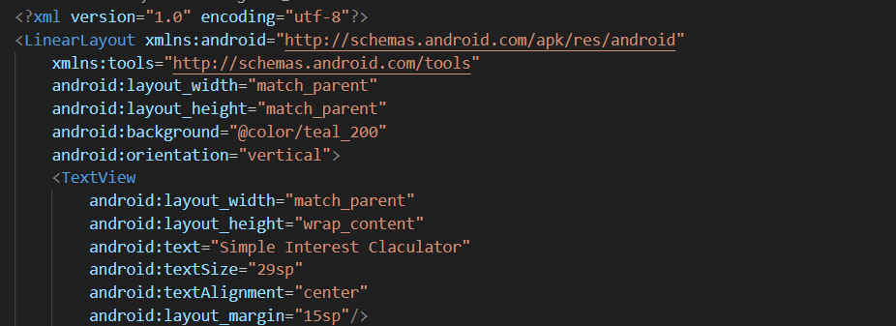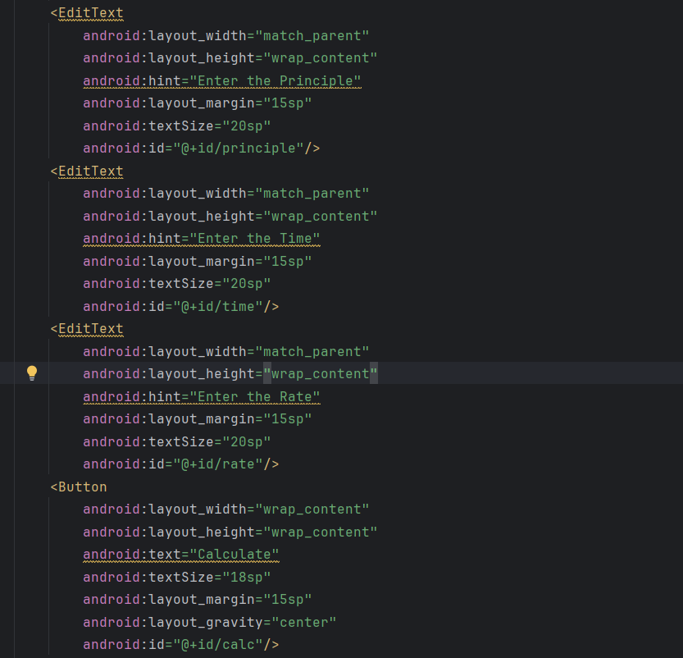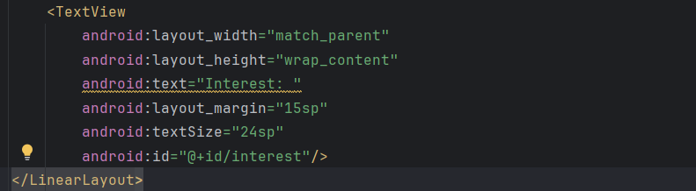

fragment_area.xml: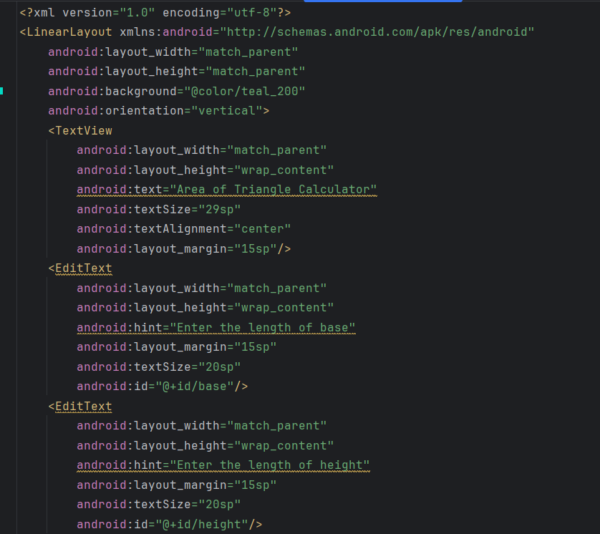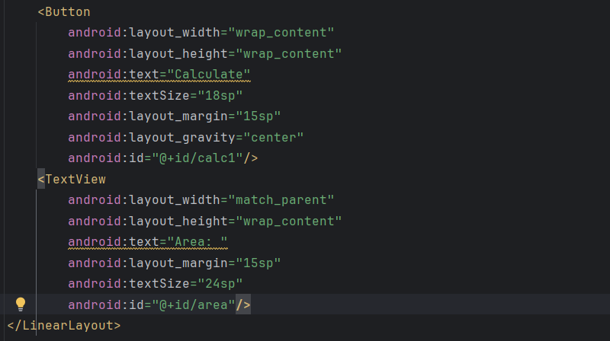

si.java:

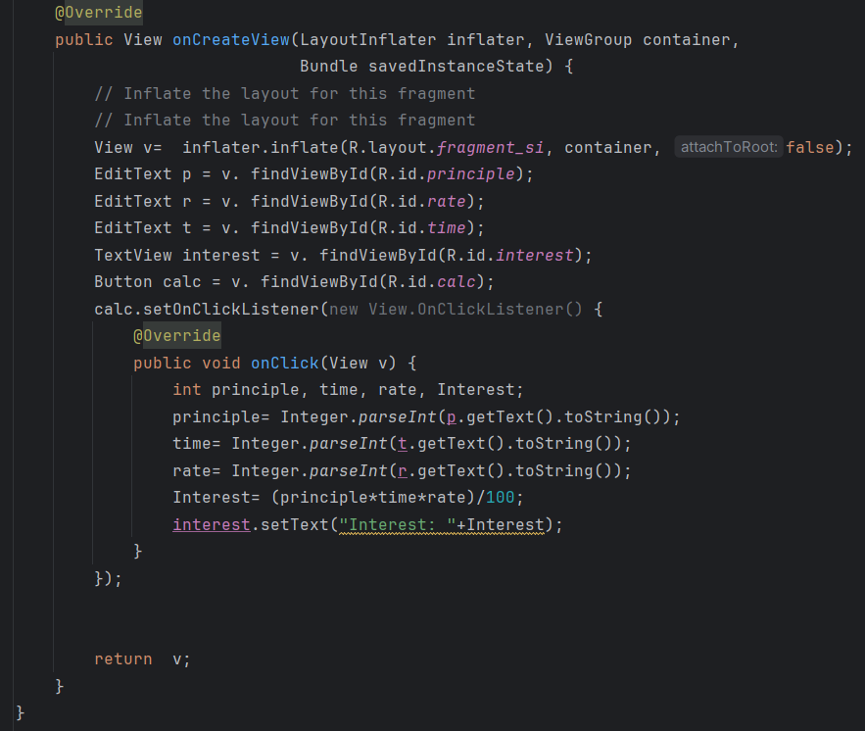

area.java:

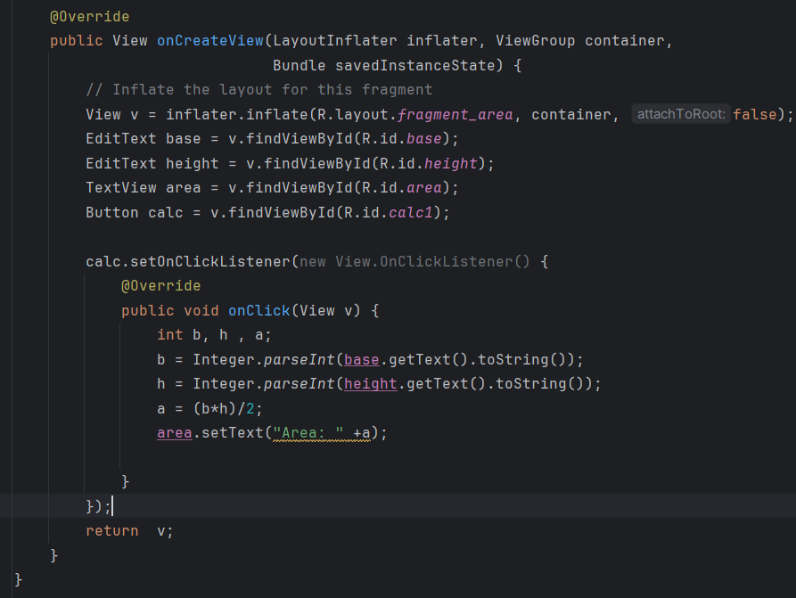

MainActivity.java:

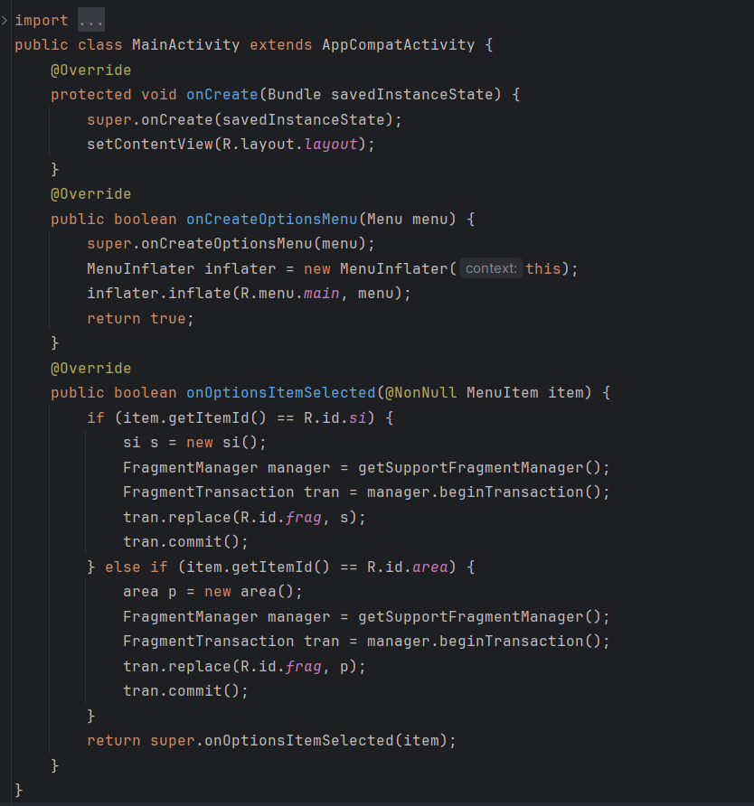

Output:

|  |  |
| --- | --- |
| Entry Screen: | Display Screen with Option Menu: |
| Display Screen with SI: | Display Screen with Area of Triangle: |

**Task 2.2:**

**Demonstrate context menu and popup menu.**

Context Menu:

layout.xml:

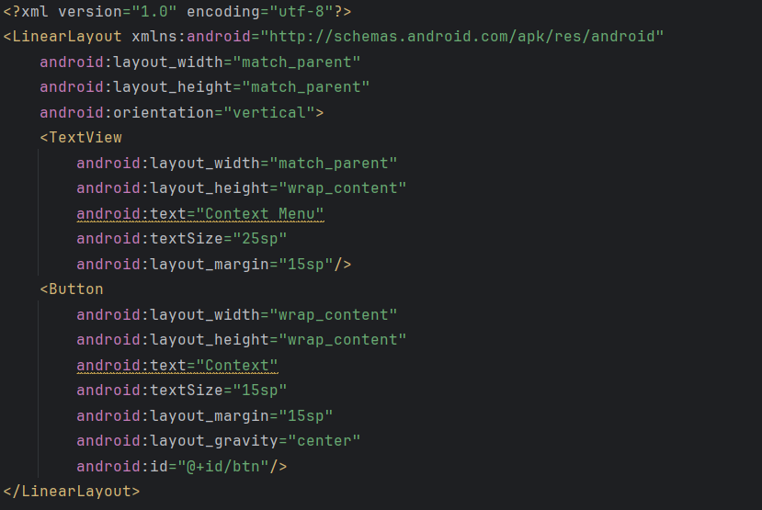

main.xml:

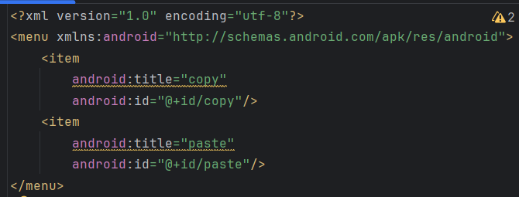

MainActivity.java:

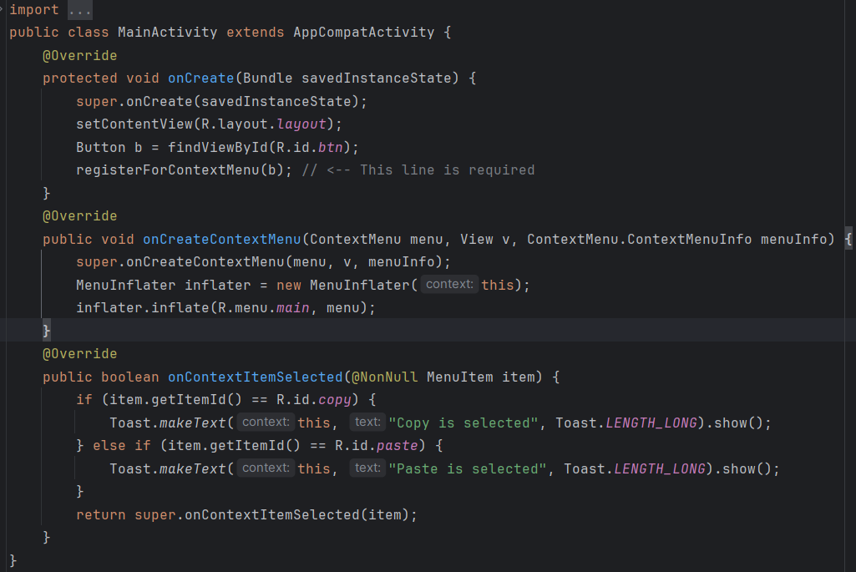

Output:

|  |  |
| --- | --- |
| Entry Screen: | Display Screen with Context Menu: |
| Display Screen when copy is clicked: | Display Screen when paste is clicked: |

Popup Menu:

layout.xml:

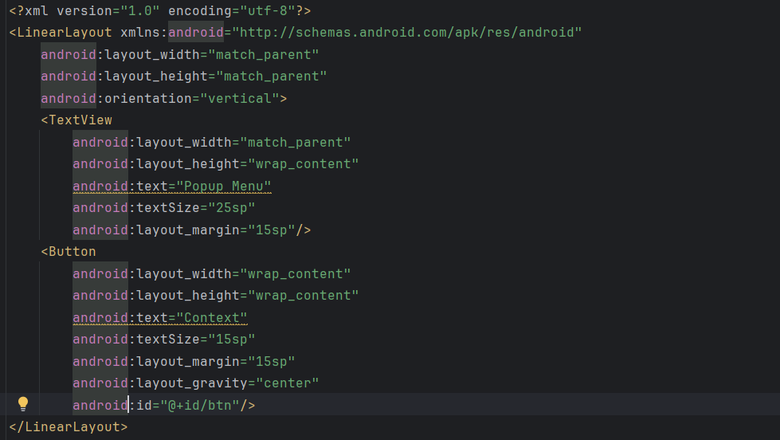

main.xml:

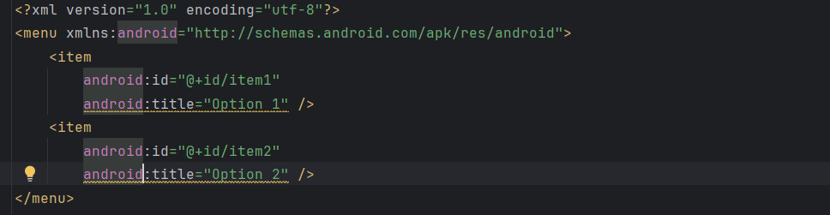

MainActivity.java:

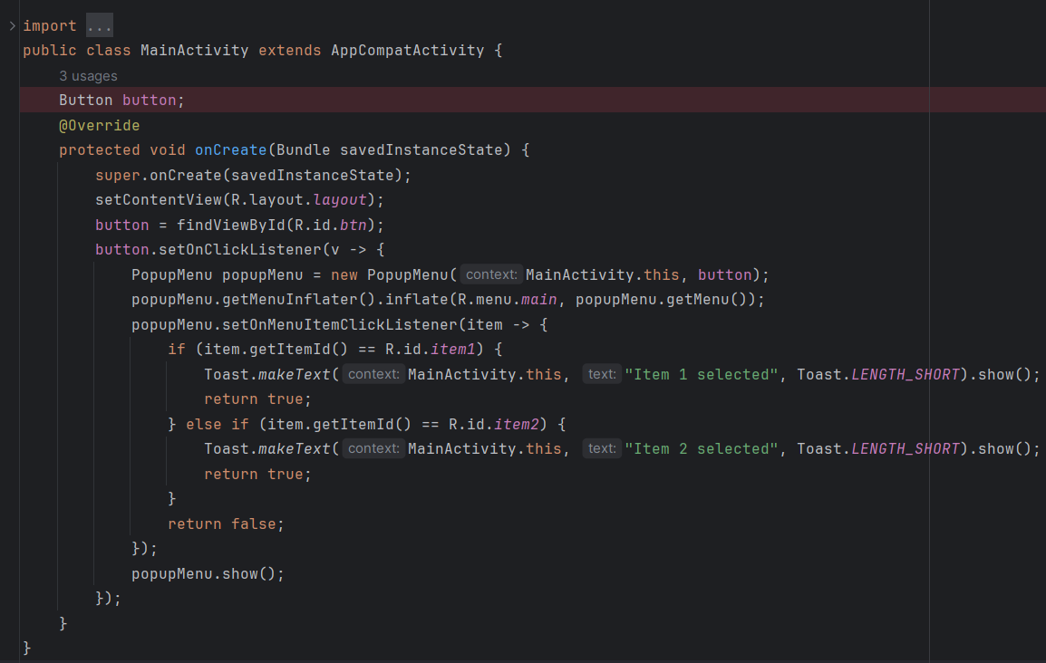

Output:

|  |  |
| --- | --- |
| Entry Screen: | Display Screen with Popup Menu: |
| Display Screen when Option 1 is clicked: | Display Screen when Option 2 is clicked: |

**Task 2.3:**

**Create an android app with custom dialog box. Dialog box should ask for Student detail (Name, roll, MP, NP, AJ, AE, DS). When save button is pressed. Student detail should be displayed in activity along with result and grade.**

Student.xml:

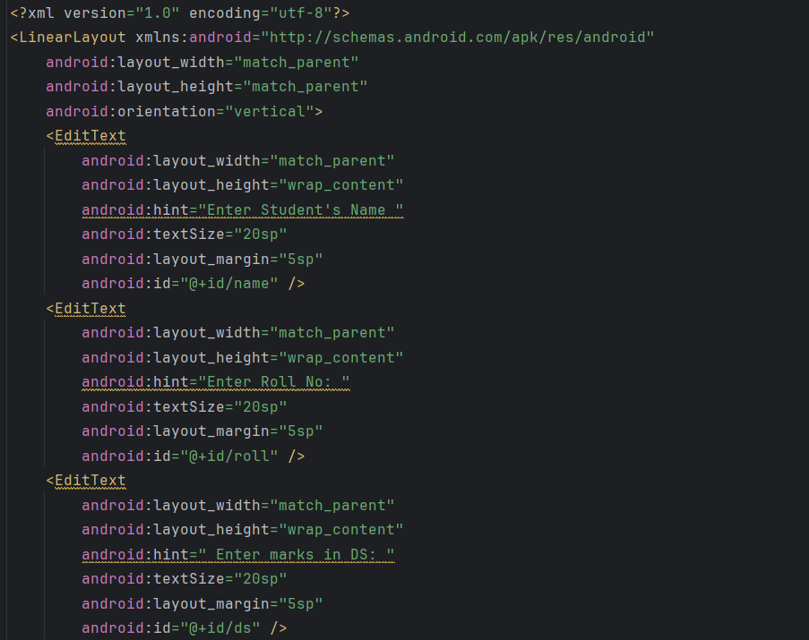

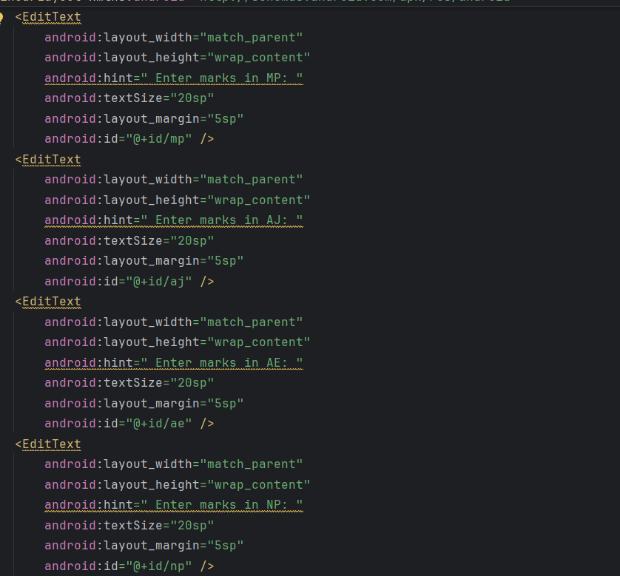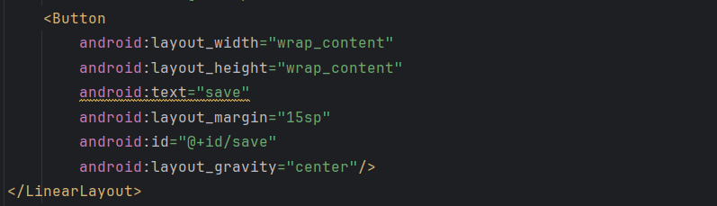

layout.xml:

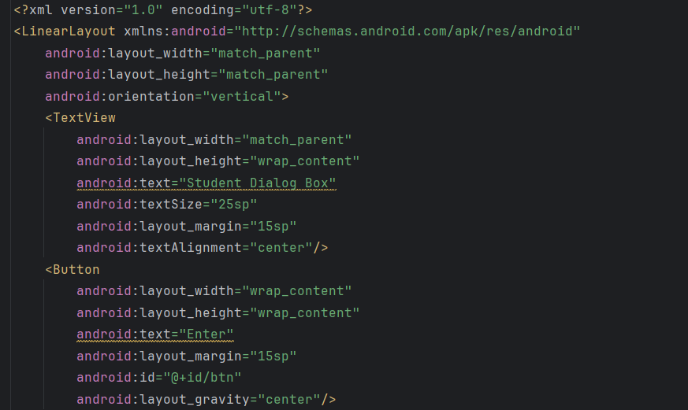

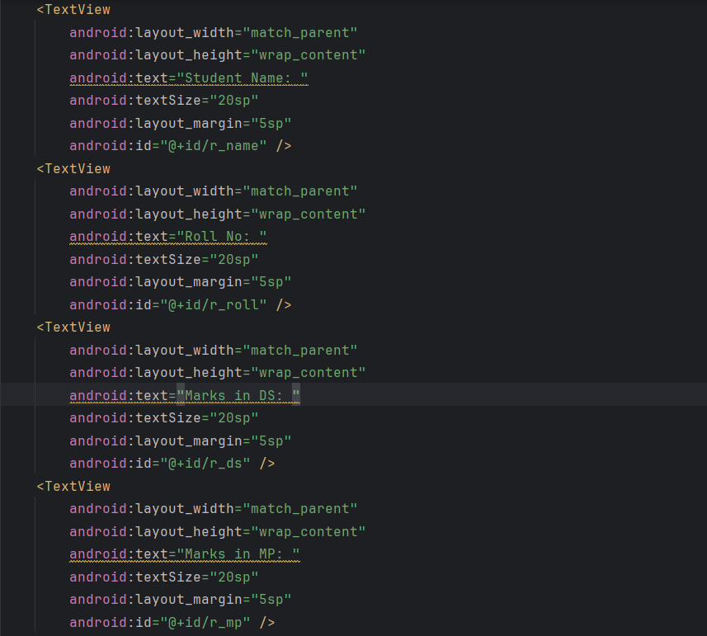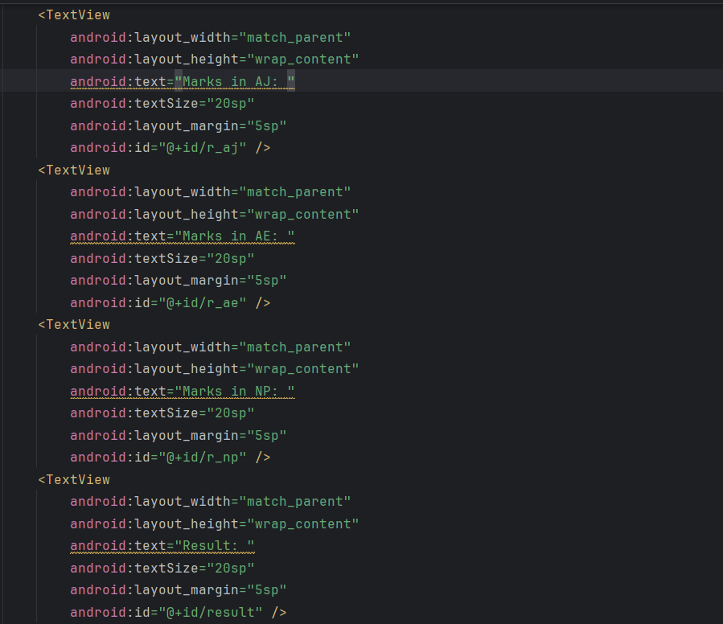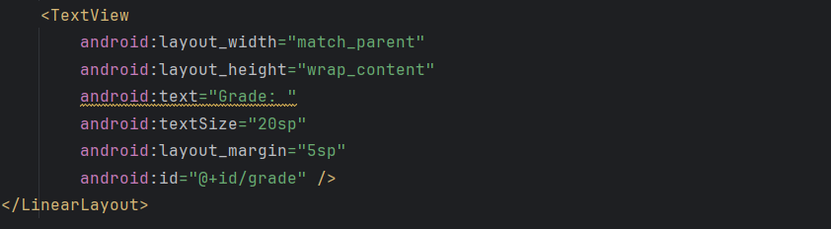

MainActivity.java: 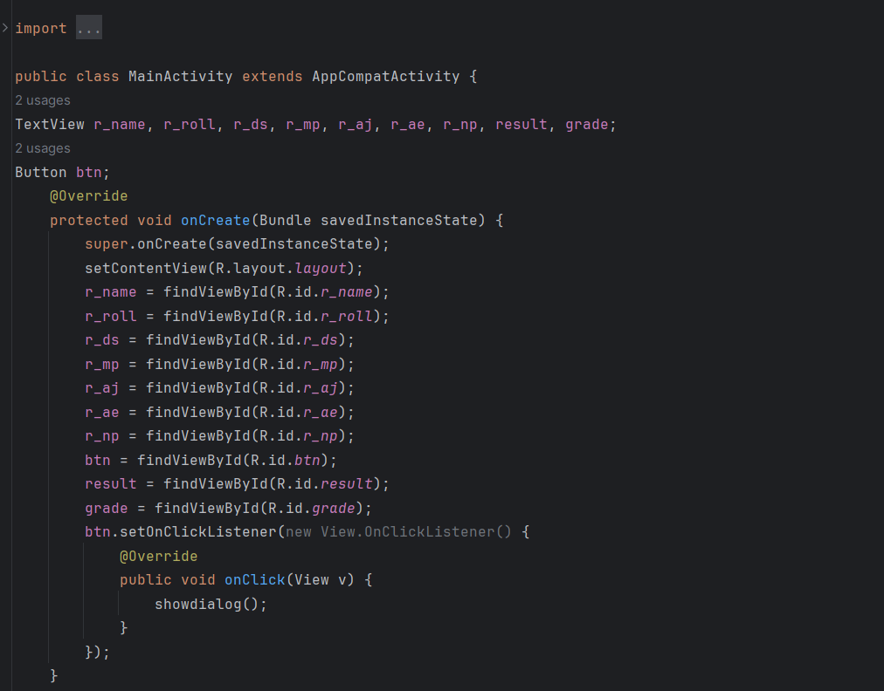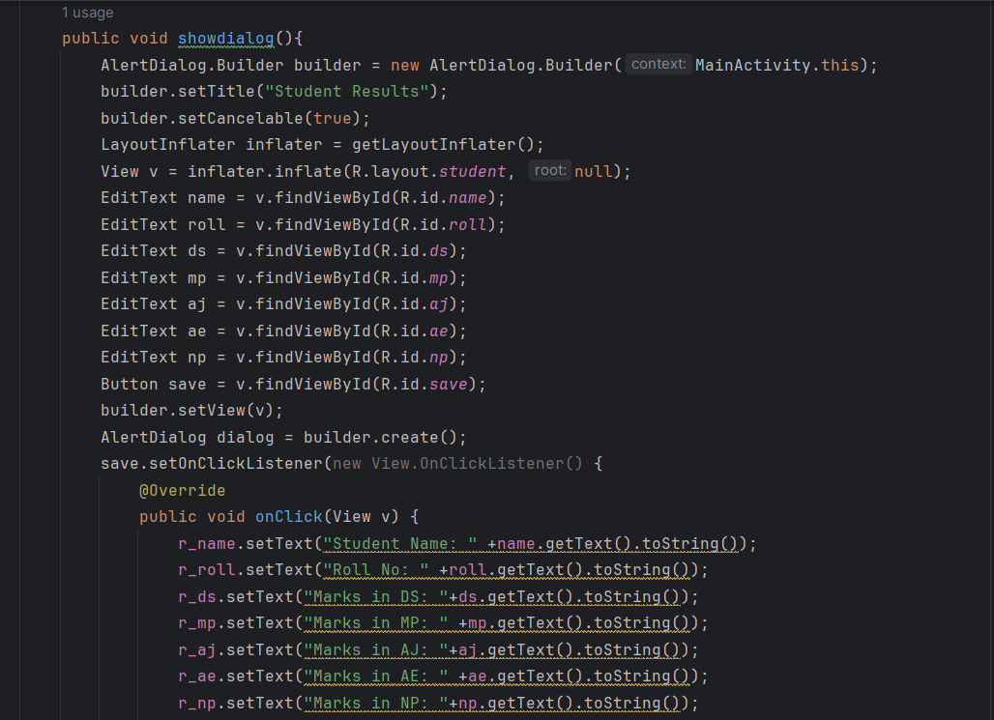

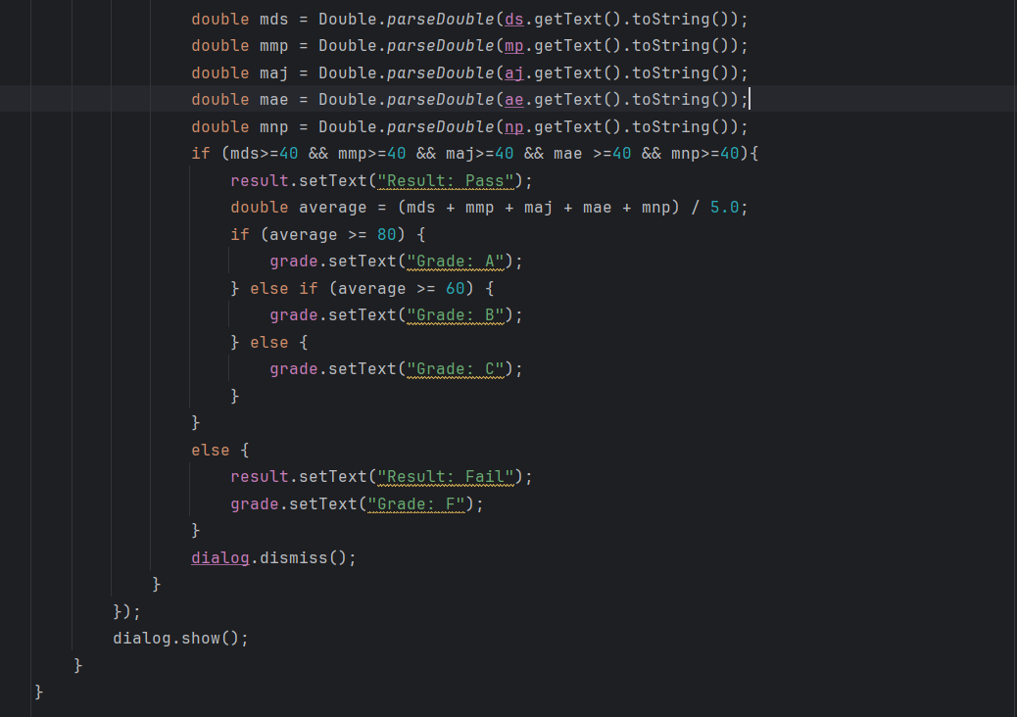

Output:

|  |  |
| --- | --- |
| Entry Screen: | Display Screen with Custom Dialog Box: |
| Display Screen when inserting data: | Display Screen with Student’s Results: |

**Task 2.4:**

**Create a Custom List View with icon.**

layout.xml:

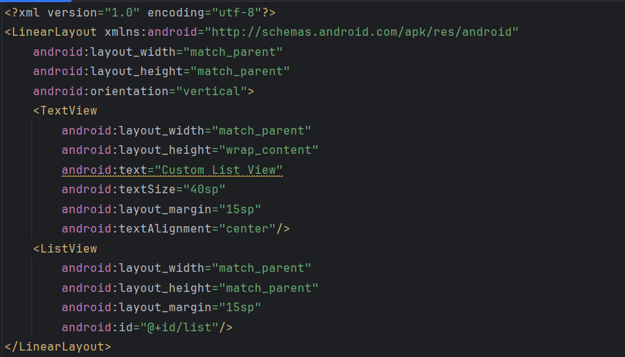

list_item.xml:

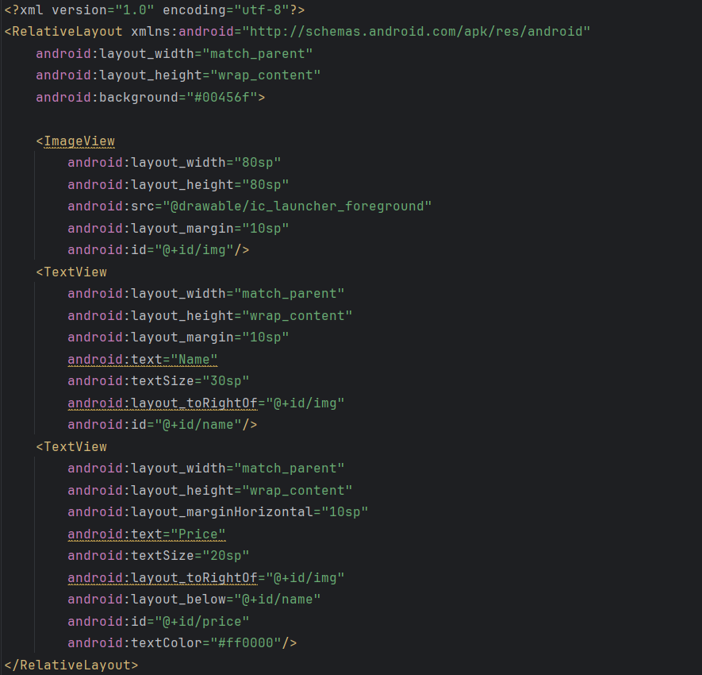

MainActivity.java:

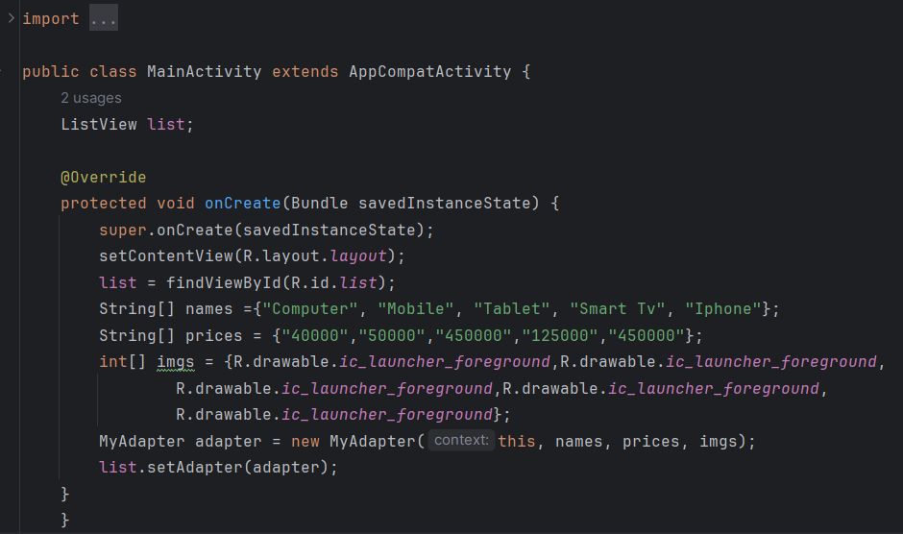

MyAdapter.java:

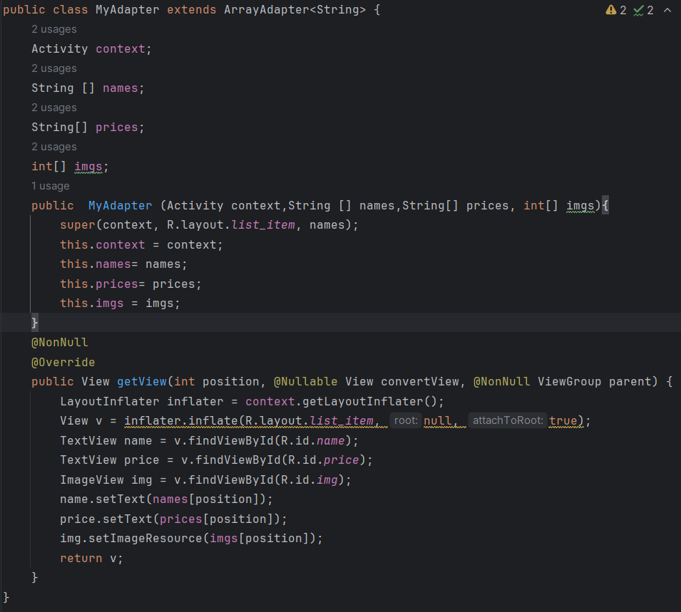

Output:

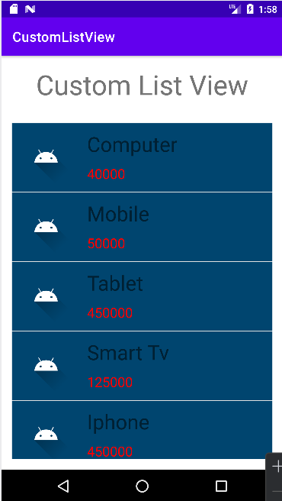

**Task 2.5:**

**Create a Custom Grid View with icon.**

layout.xml:

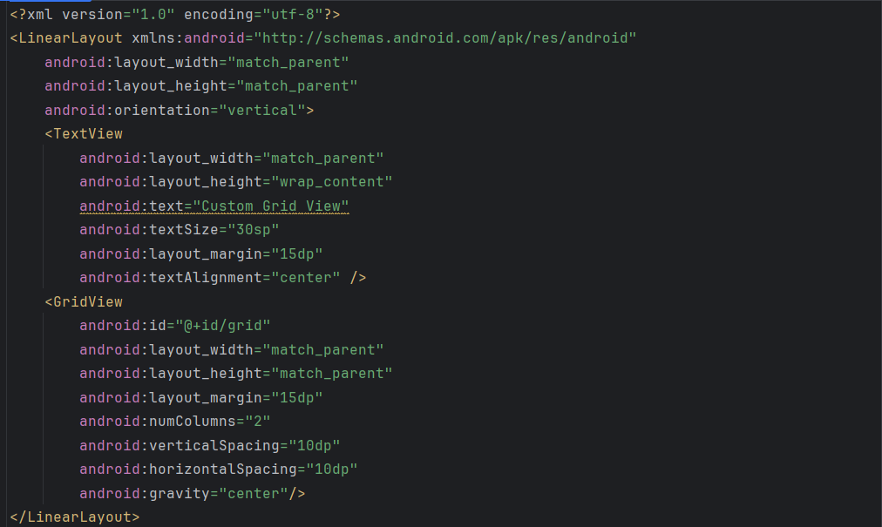

list_item.xml:

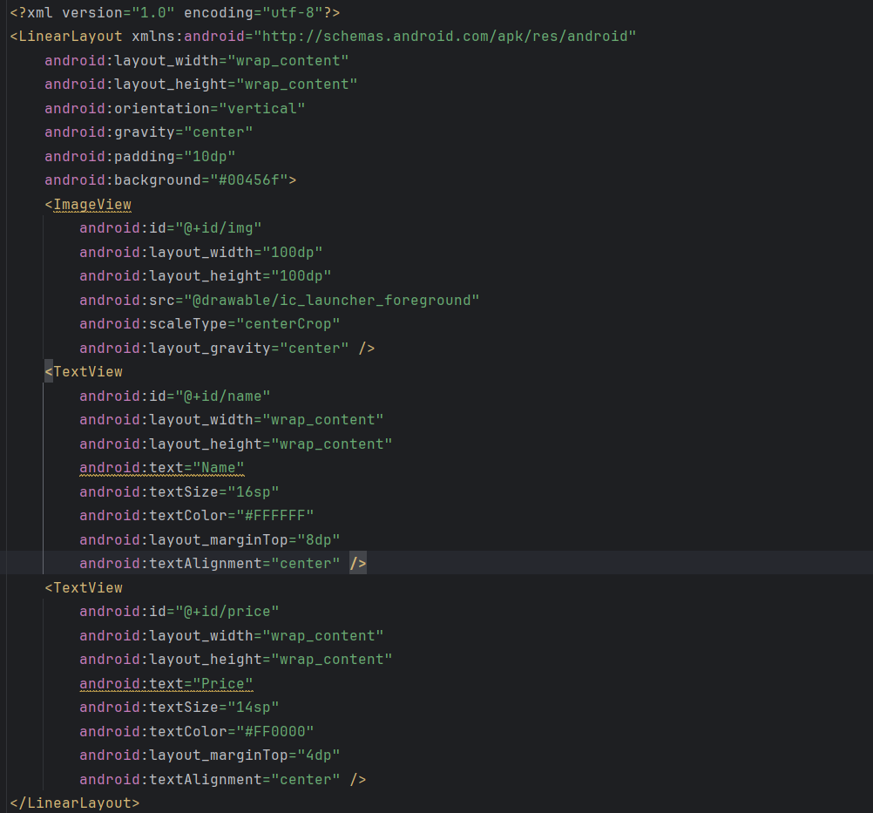

MyAdapter.java:

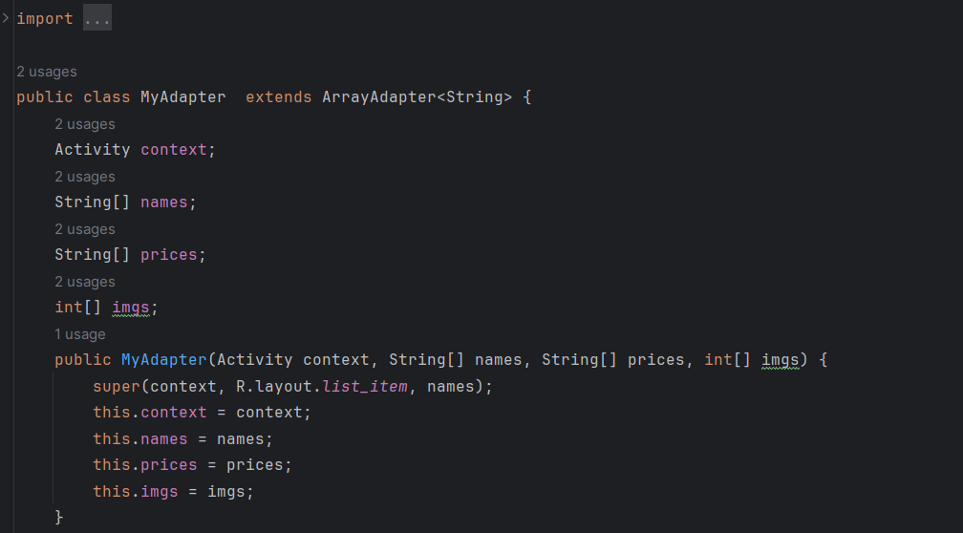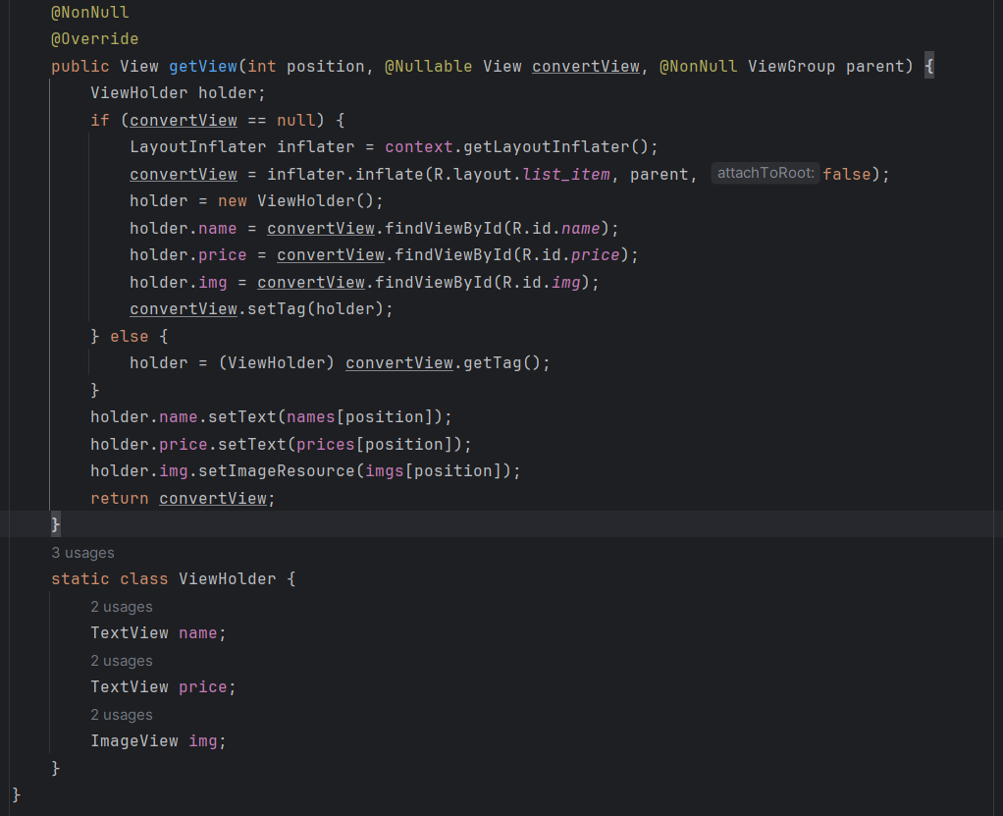

MainActivity.java:

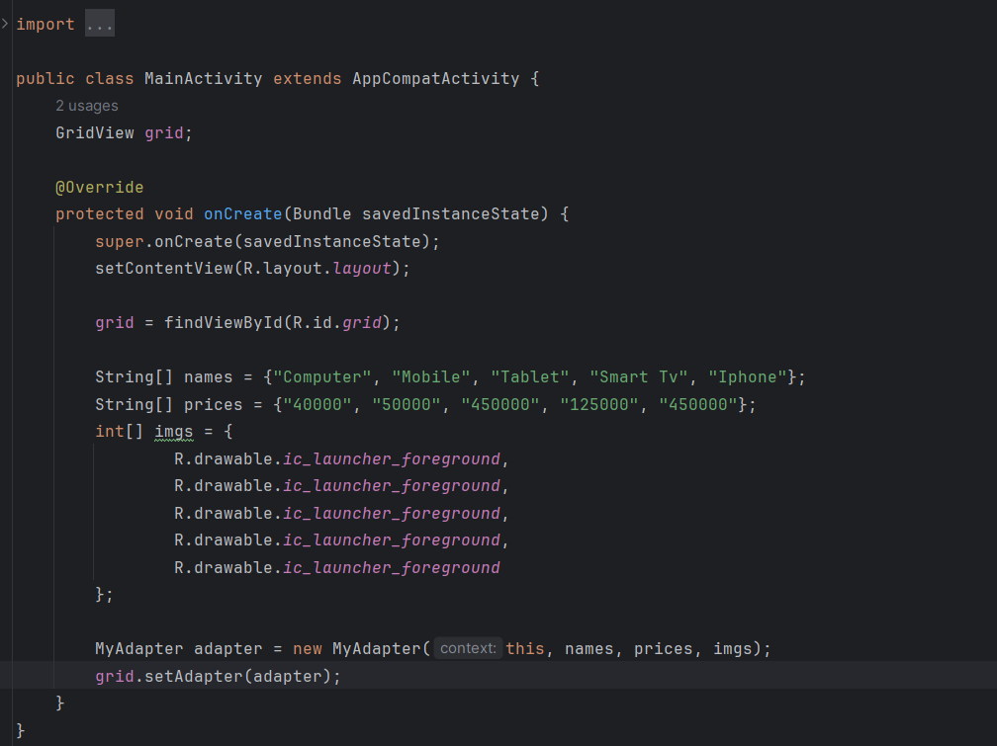

Output:

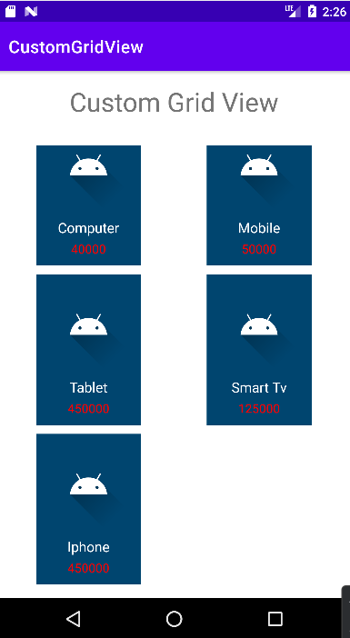

**Task 2.6:**

**Create a Recycler View with Icon and event.**

activity_main.xml: 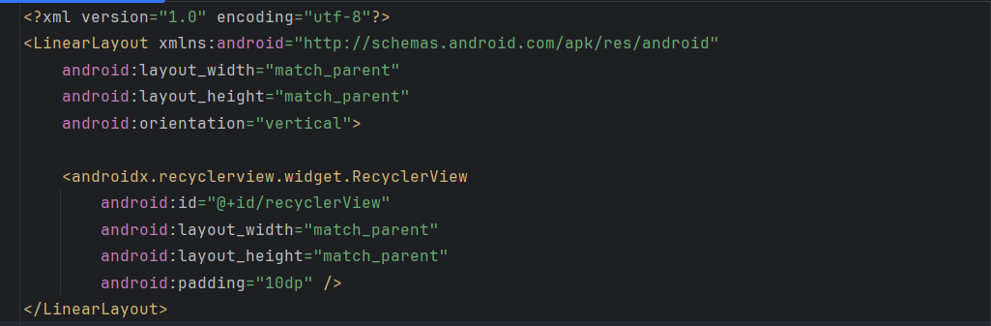

item_view.xml:

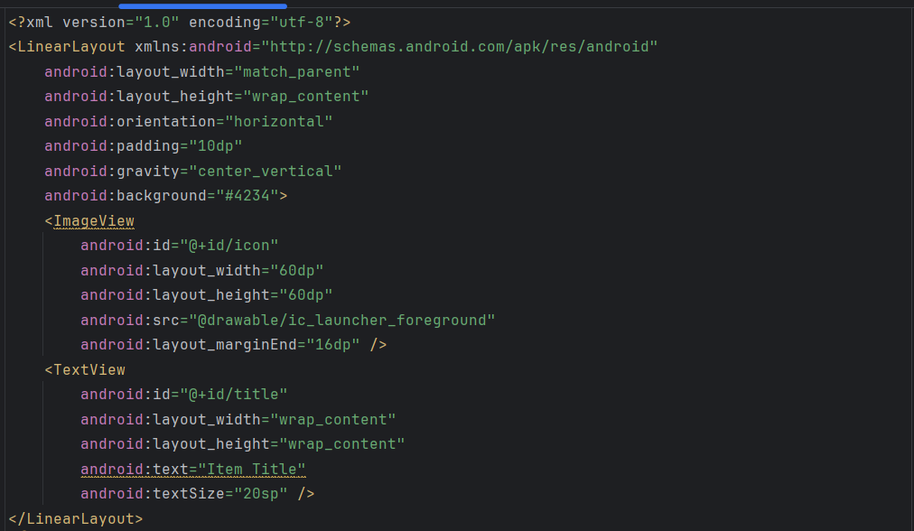

MyAdapter.java: 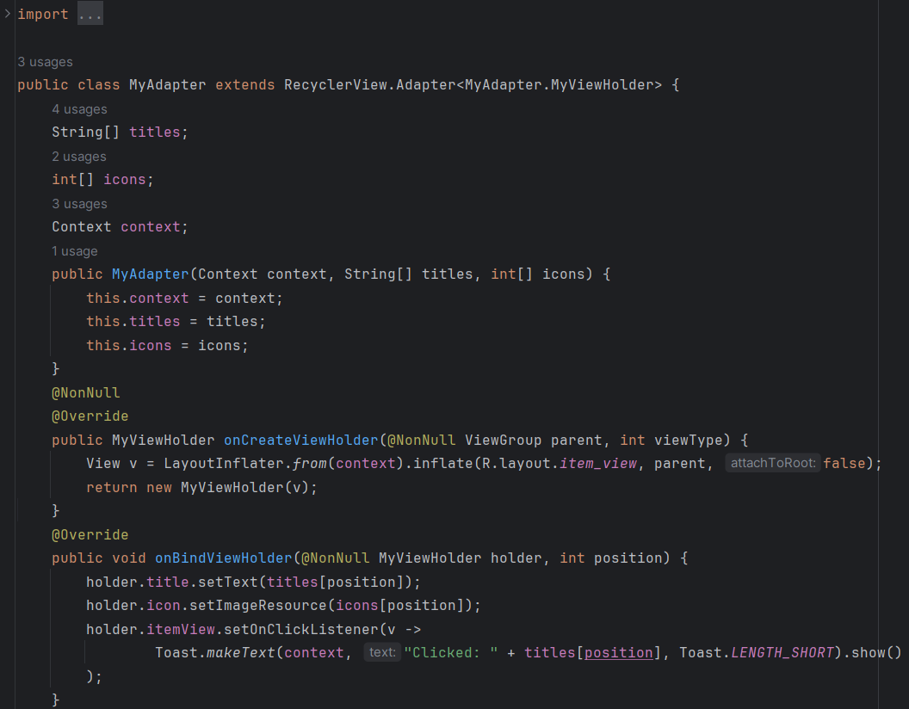

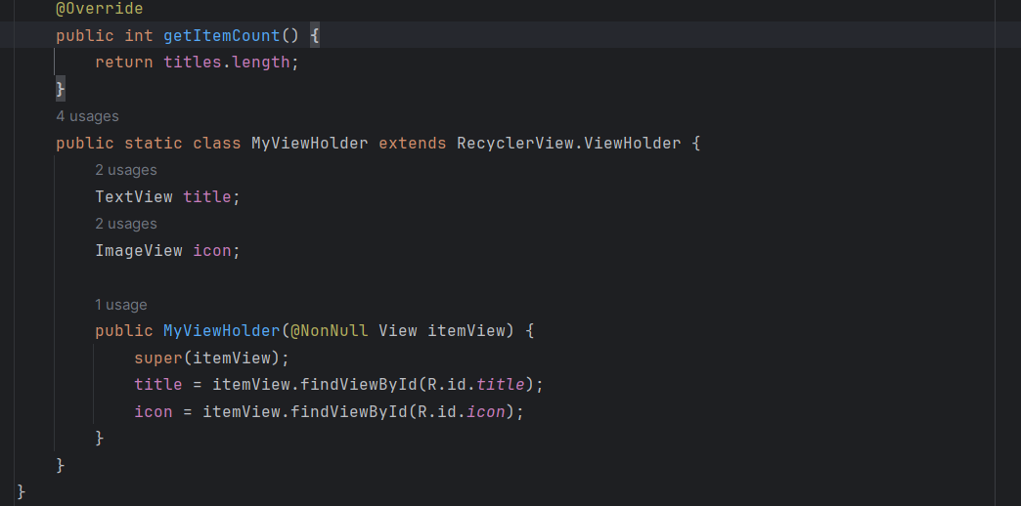 

MainActivity.java: 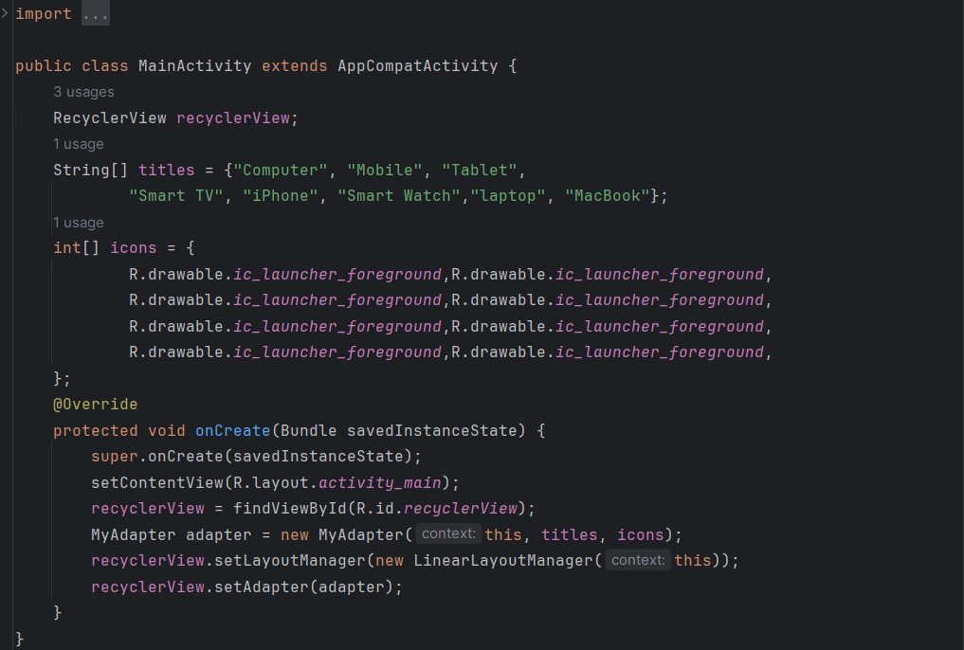

Output:

|  |  |
| --- | --- |
| Display Screen with Recycler View: | Display Screen when an item is clicked: |
|  |  |